Chapter 11, Problem 22.

Find the rms value of the offset sine wave shown in Fig. 11.53.

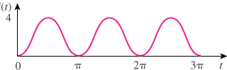

Figure 11.53
For Prob. 11.22.

